  SNIR | Basic video worksheet  Computer Networking tutorial |   ESLA

Watch the video and answer the following questions:
- What is the router (ˈraʊtə) connected to?
The router is connected to the computers and the modem.
- What are the two types of routers? What’s the difference of setting up? What’s the difference of use?
The two types of routers are a wireless router and a wire router.
- What is the role of a router?
The role of a router is a networking device that forwards data packets between computer networks.
- Reproduce the diagram representing the Home Network
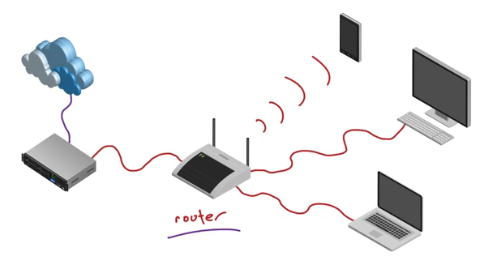
- Bonus question: Is a router enough to have access to the Internet? Explain.
A router isn’t enough to have access to the Internet because we need an Internet modem.

